HD
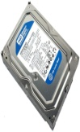 | WD Caviar Blue 500 GB | - 500 GB HDD  - 7200 RPM Spin Speed  - 16 MB Cache Memory  - SATA 6.0 Gbps Interface  - 4800 Mbps I/O Transfer Rate | Rs. 3500 | 0 | Rs. 3500
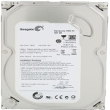 | Seagate Barracuda 500 GB | - 500 GB HDD  - 7200 RPM Spin Speed  - 16 MB Cache Memory  - SATA 6.0 Gbps Interface  - 4800 Mbps I/O Transfer Rate | Rs. 5700 | 38 | Rs. 3520
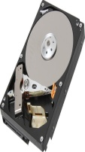 | Toshiba 500 GB | - 500 GB HDD  - 7200 RPM Spin Speed  - SATA 6.0 Gbps Interface  Average Seek Time - 0.8 ms  - 300000 Load / Unload Cycles | Rs. 3766 | 0 | Rs. 3766
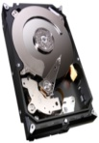 | Seagate Barracuda 1 TB | - 1 TB HDD  - 7200 RPM Spin Speed  - 64 MB Cache Memory  - SATA 6.0 Gbps Interface  Average Seek Time - 9.5 ms | Rs. 6500 | 34 | Rs. 4290
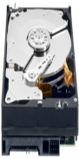 | WD 1 TB | - 1 TB HDD  - 7200 RPM Spin Speed  - 64 MB Cache Memory  - SATA 6.0 Gbps Interface  - 300000 Load / Unload Cycles | Rs. 6179 | 0 | Rs. 6179
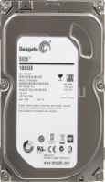 | Seagate Barracuda SV-35 1 TB | - 1 TB HDD  - 7200 RPM Spin Speed  - 64 MB Cache Memory  - SATA 6.0 Gbps Interface  - 300000 Load / Unload Cycles | Rs. 7500 | 36 | Rs. 4729
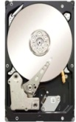 | Seagate Constellation ES 2 TB | - 2 TB HDD  - 7200 RPM Spin Speed  - 64 MB Cache Memory  Average Seek Time - 9.5 ms  - SATA 6.0 Gbps Interface | Rs. 16000 | 6 | Rs. 14890
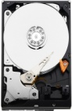 | WD Caviar Green 2 TB | - 2 TB HDD  - 64 MB Cache Memory  - SATA 6.0 Gbps Interface  - 2400 Mbps I/O Transfer Rate  - 300000 Load / Unload Cycles | Rs. 9500 | 33 | Rs. 6340
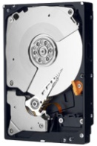 | WD 2 TB | - 2 TB HDD  - 7200 RPM Spin Speed  64 MB Cache Memory  - SATA 6.0 Gbps Interface  - 300000 Load / Unload Cycles | Rs. 10058 | 0 | Rs. 10058
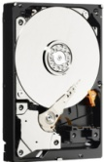 | WD Caviar Green 3 TB | - 3 TB HDD  - 64 MB Cache Memory  - SATA 6.0 Gbps Interface  - 3.5 inch Form Factor  - 300000 Load / Unload Cycles | Rs. 9095 | 0 | Rs. 9095
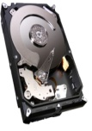 | Seagate Barracuda 3 TB | - 3 TB HDD  - 7200 RPM Spin Speed  - 64 MB Cache Memory  - 600 MBps I/O Transfer Rate  - SATA 6.0 Gbps Interface | Rs. 13000 | 34 | Rs. 8539
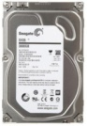 | Seagate Barracuda SV-35 3 TB | - 3 TB HDD  - 7200 RPM Spin Speed  - 64 MB Cache Memory  - 600 MBps I/O Transfer Rate  - SATA 6.0 Gbps Interface | Rs. 16000 | 40 | Rs. 9450

